Setting up the eChronos environment

The provided instructions are for Windows Systems. Adaptation will be necessary for other systems.

Note: most of the images in this document link to larger images that give a better view

Section 1 - Initial software setup
This section walks you through the setup of the following programs:
- Eclipse – the program we use to organize and edit our code, makes our lives easier
- Java Development Kit (JDK) – some underlying resources necessary for using Java
- Open Office – basically the same as Microsoft Office, but free!
- Subclipse – plug-in for Eclipse, helps us all have the same code to work with

Eclipse
- Click here to go to the download page for Eclipse v. 4.2 (Juno). On the right, click on the correct link for your operating system. |  | 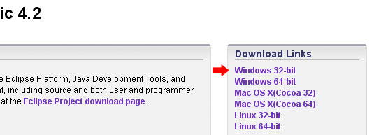
- Unzip the file into your Program Files folder After downloading you can right-click and drag the file into your Program Files folder, then click ‘Extract Here’. It is recommended that you not use the default Windows unzipping utility, but instead use 7-zip (free) or another 3rd party tool. Click here for more help/details. Alternatively you can double-click the downloaded file and drag the ‘eclipse’ folder into your Program Files folder. |  | 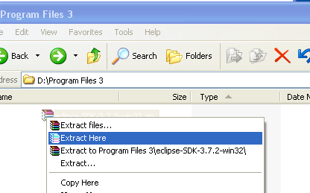
- To run Eclipse, open the folder you just extracted and find the eclipse.exe file. Double-click it. To set up Shortcuts, you can drag this file into the Task Bar or into the Start Menu. |  | 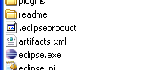
- When you run Eclipse it should prompt you to enter the name of a workspace. You can accept the default or create a separate workspace for Carolla Development projects (e.g., workspace_CarollaDevelopment). Often users of Eclipse have multiple workspaces to separate related projects. |  | 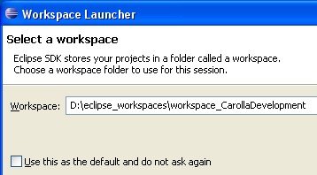
- When eclipse runs for the first time it displays the welcome screen. Click on the Workbench icon at the top right to go to Eclipse’s default layout (also called Perspective) . |  | 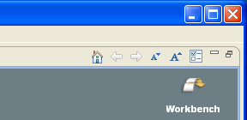

JDK
- Click here to download the Java SE 6 JDK  Be sure to choose the appropriate download for your operating system |  | 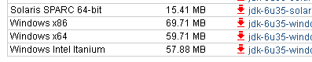
- Run the installer  Click here for help with installation. |  | 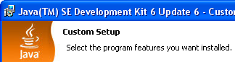

Open Office
- Click here to download Open Office |  | 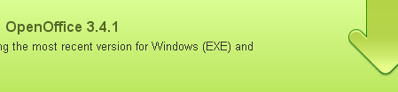
Run the installer. Click here for installation help from the Open Office website

Subclipse - Subclipse may be generically referred to by the team as ‘Subversion’
- Open Eclipse  - Go to Help > Install New Software… |  | 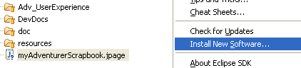
- Paste http://subclipse.tigris.org/update_1.8.x/ into the ‘Work with’ field and hit ‘Enter’ |  | 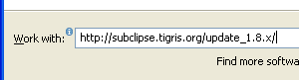
- You should now see ‘Subclipse’ and ‘SVNKit’ under ‘Name’ |  | 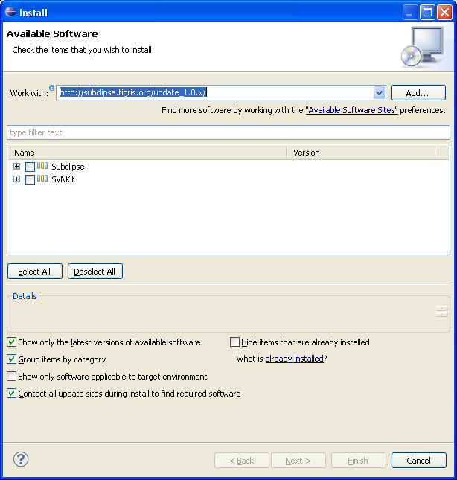
    - Click ‘Select All’ underneath the two options
    - Click ‘Next’. Click ‘Next’ again. Click to accept the license agreements, and then click Finish

    - If you get a warning about ‘unsigned content’ during the installation, just click ‘OK’. The rest of the team did so and our computers did not implode.
    - When prompted, click ‘Restart Now’ to restart Eclipse

Alternatives: if you prefer not to use Eclipse

TortoiseSVN
- Download: http://tortoisesvn.net/downloads.html
- To Synchronize with ProjectLocker: http://tortoisesvn.net/docs/release/TortoiseSVN_en/tsvn-dug-checkout.html

Section 2 - Working with Subclipse and ProjectLocker:

Connecting to the Repositories - To work with the Team’s files you have to connect to their storage location in the ProjectLocker repositories

- Get your username and password from one of the project administrators (Tim or Al). They must set up an account for you before you can connect.  - Go to the ProjectLocker Website and sign in  - If signing in fails and you’re confident your credentials were entered correctly you may need to bug the admins to see if they set your permissions properly. |  | 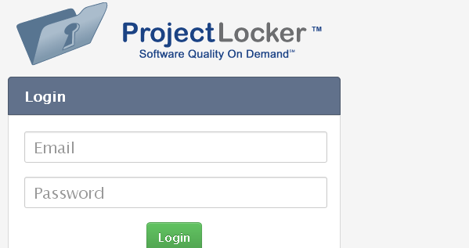
- After successful login, open up Eclipse  - Change the perspective to ‘SVN Repository Exploring’ by clicking on the double-arrows at the upper right hand of the interface and selecting it from the drop-down. |  | 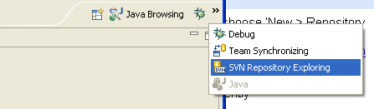
- Now on the left-hand side, right-click in the ‘SVN Repositories’ window and choose ‘New > Repository Location…’ |  | 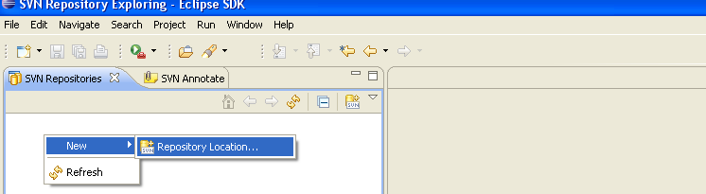
- In the ‘Url:’ field type: https://pl3.projectlocker.com/CarollaDevelopment/Adventurer/svn  - Click ‘Finish’ |  | 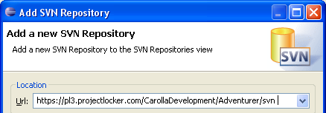
- Enter your username and password  - You will probably want to check ‘Save Password’  - At the prompt for the Digital Certificate, click ‘Accept Permanently’ |  | 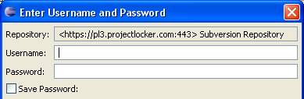
- Repeat steps 6 through 10 for the following repositories:
https://pl3.projectlocker.com/CarollaDevelopment/Chronos/svn
https://pl3.projectlocker.com/CarollaDevelopment/QuestMaster/svn
https://pl3.projectlocker.com/CarollaDevelopment/MyLib/svn

Checking out Project Files - To use the files you connected to in the previous step, you must use the ‘checkout’ feature

- In the ‘SVN Repository Exploring’ perspective, click on the ‘plus’ symbol next to https://pl3.projectlocker.com/CarollaDevelopment/Adventurer/svn to expand the location.  - Right-click on the ‘Adventurer’ folder and select ‘Checkout…’ |  | 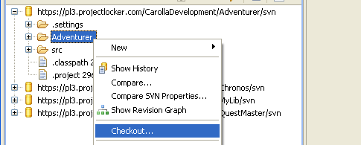
- Click on ‘Check out as a project configured using the New Project Wizard’  - Click ‘Finish’ |  | 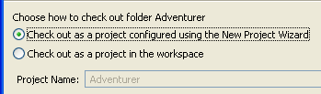
- Select ‘Java Project’ and hit ‘Next’ |  | 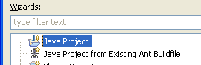
- Type in ‘Adventurer’ for the project name and hit ‘Finish’ |  | 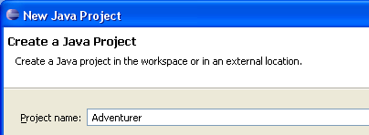
- Click ‘OK’ on the Confirm Overwrite dialog |  | 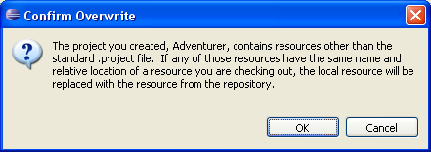
- Repeat these steps for the other 3 projects, selecting the interior folder for each project as you did for Adventurer. A heads up: the folder for MyLib is actually called ‘MyLib2’. Also, there are plenty of files and folders that you can simply ignore such as the ‘DgnWizard’ folder inside the QuestMaster repository.

Synchronizing Updated Files from the Team
When other members of the team have updated code and you want to download the changes. The following steps are the quickest way to update all changes from the team

- Open the ‘Team Synchronizing Perspective’  - In the ‘Synchronize’ tab on the left click on the ‘Synchronize’ button. This will check for any changes since the last update. |  | 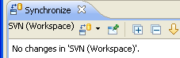
- When it finishes, click on the ‘Update All Incoming Changes’ button. |  | 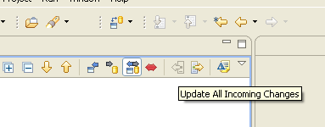

Synchronizing Your Own Updates
When you update code and want to submit the changes… [need help filling this in]

Section 3 – Finishing Touches:

Missing Pieces
A few more things need to be done to finish up. If you happen to have looked at the Package Explorer and if you’ve followed the steps in this document up to this point, you may have noticed some of the red Xs next to the packages in the 4 projects. These represent problems with the code. The reason there are so many is that you need to tell each project where to find resources in the other projects. Here’s how:

- Select the Adventurer project and right-click it. Then click on ‘Properties’ at the bottom of the menu. |  | 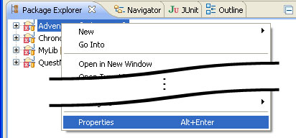
- Click on ‘Java Build Path’ on the left. Click on the Projects tab and then click the ‘Add…’ button. |  | 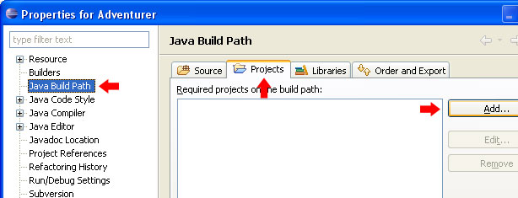
- Click the boxes next to Chronos and MyLib. |  | 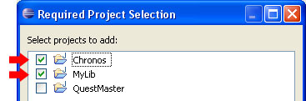
- Now go to the ‘Libraries’ tab and click on the ‘Add Externa JARs…’ button. |  | 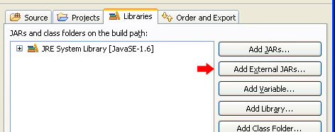
- Navigate to the ‘libResources’ folder inside the MyLib Project. The path relative to your workspace should be ‘…\MyLib\src\mylib\ libResources’ |  | 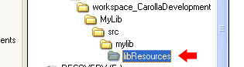
- Select both the ‘db4o’ and the ‘migLayout’ jar files and click ‘Open’. |  | 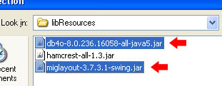
- Still in the ‘Libraries’ tab, click on the ‘Add Library…’ button. |  | 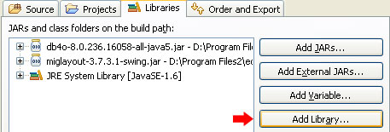
- In the pop-up window, select ‘JUnit’ and click ‘Next’ |  | 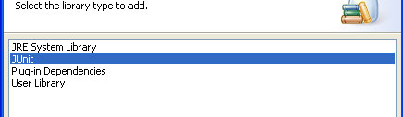
- Select ‘JUnit 4’ from the drop-down menu. Press ‘Finish’. |  | 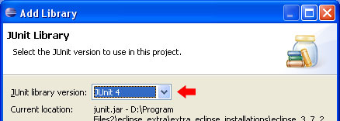
- Here’s how it should look after adding the Libraries. |  | 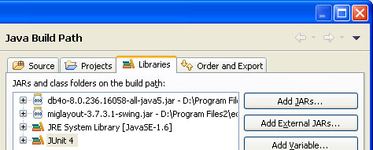
- Go to the Project Properties for the Chronos Project. In the Projects Tab add ‘MyLib’. In the Libraries Tab add ‘db4o’ and ‘hamcrest’ as External Jars and JUnit 4 as a Library. |  | 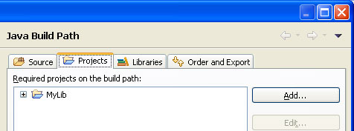  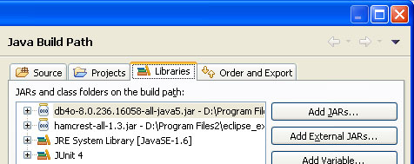
- Similarly for the MyLib Project, open up its Properties. Add ‘db4o’ and JUnit 4. |  | 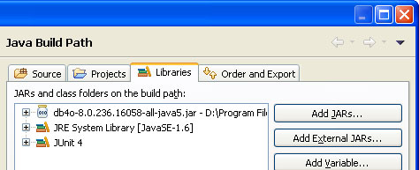
- And finally for the QuestMaster Project, open up its Properties. Add ‘Chronos’ and ‘MyLib’ in the Projects tab, and add ‘db4o’ and JUnit4 in the Libraries tab. |  | 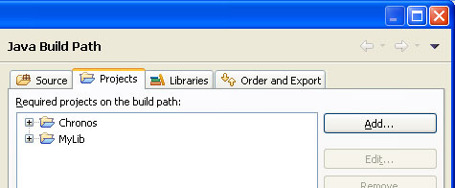  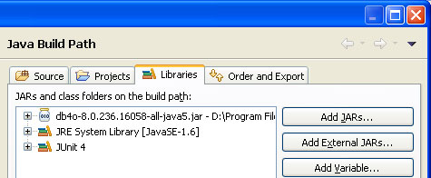

That should take care of most of the errors. The remaining ones should be problems that need to be solved through code revision. That’s where you come in! Welcome to the front lines of the Chronos “Campaign” and good luck out there soldier!

